**Sensor simulation:**

Using the simulation website [www.tinkercad.com](http://www.tinkercad.com), we tried to create a circuit that includes the Digital Temperature sensor. Unfortunately, among the Components of the simulator, we could only find a TMP36 Temperature sensor. Thus we simulated the circuit for the **Analog Temperature**. In order to do this we used an Arduino Uno R3, the TMP36 Temperature sensor and wires. The result was constant and had the following value: 24.71°C.

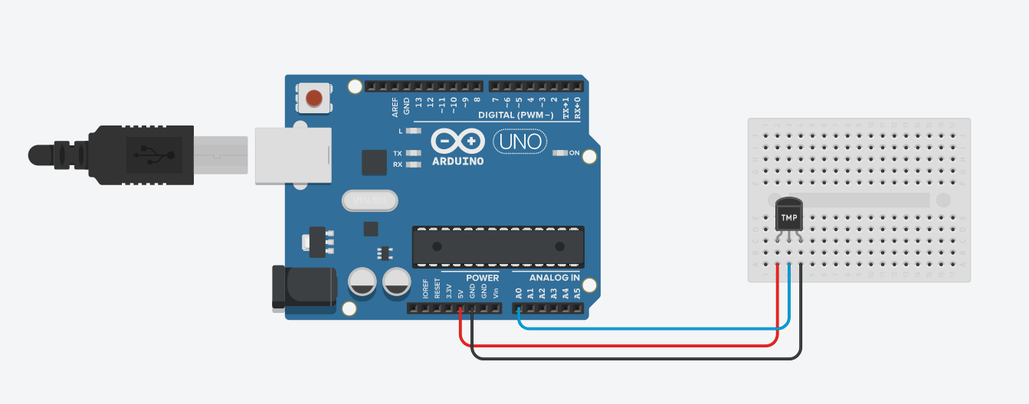

**The circuit created using tinkercad.com – Analog Temperature sensor**

You may find the circuit we built at the following URL link:

[**https://www.tinkercad.com/things/bxZYUC7Lz00**](https://www.tinkercad.com/things/bxZYUC7Lz00)